Name | : | KALEELRAHMAN S
Project Name | : | TN Police Dog Squad System
Number of Project | : | 1

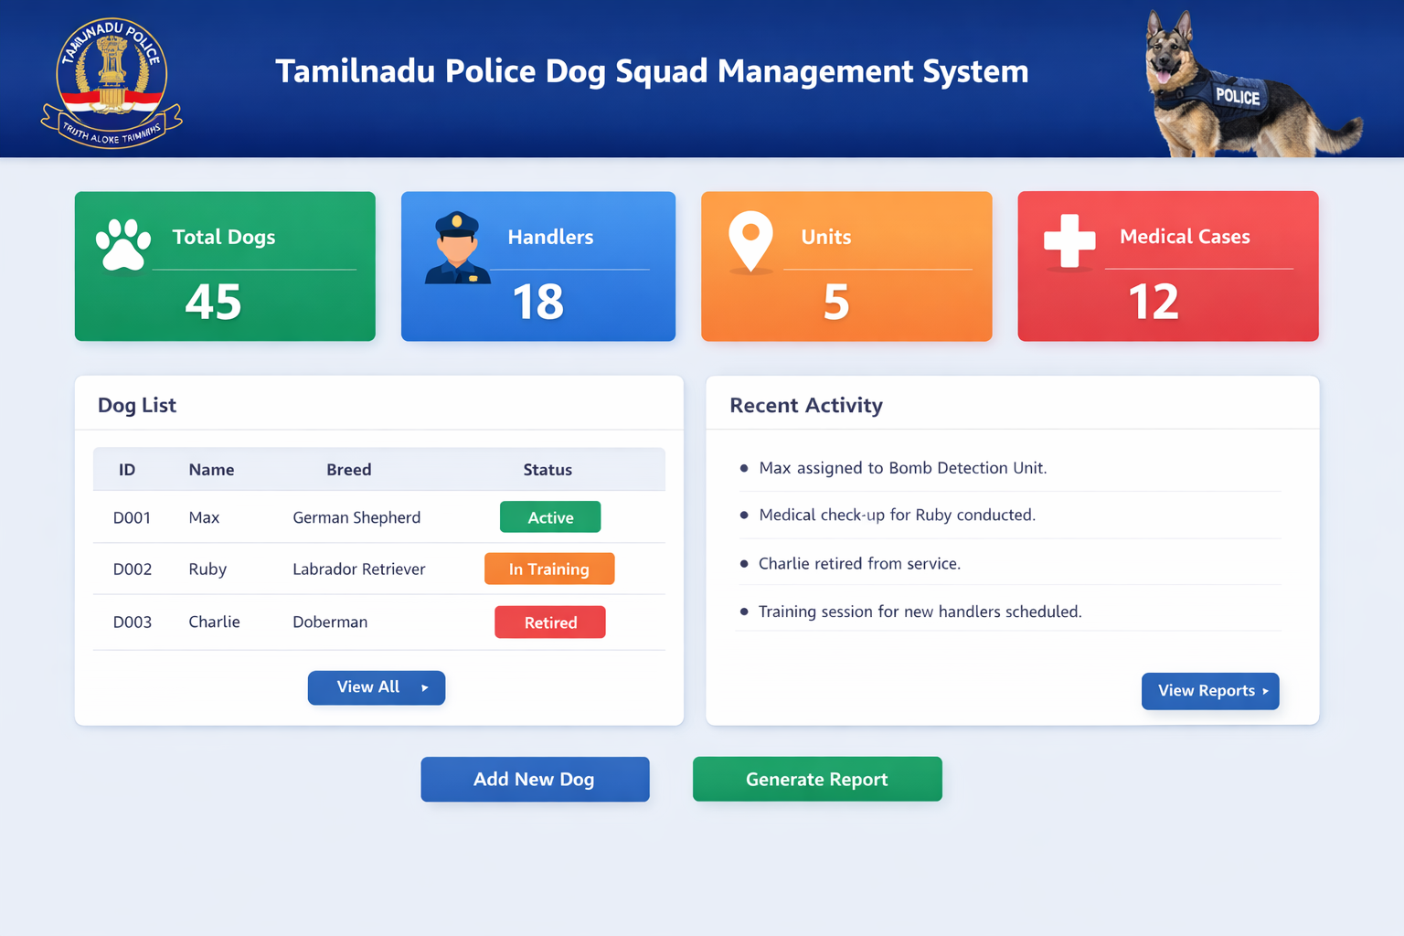

Tamil nadu Police Dog Squad - Project Documentation

Agenda
1. Introduction about Tamilnadu Police Dog Squad Website
2. Objective of the Project
3. Features of the Website
4. Technologies Used
5. How the Website Works
6. Conclusion

Introduction
The Tamilnadu Police Dog Squad website is developed to provide information about police dog units, their training, services, and achievements. This project is created using Angular for frontend development.

Objective of the Project
The main objective of this website is to create awareness about the Tamilnadu Police Dog Squad and showcase their role in crime investigation, security services, and public safety.

Technologies Used
• Angular (Frontend Framework)
• HTML
• CSS
• Type Script

How the Website Works
The website loads the homepage with basic information about the dog squad. Users can navigate through different sections to learn about breeds, training, and services. The application runs in a browser and is developed as a frontend project.

Project Screenshot
<< Insert Project Screenshot Here >>

Conclusion
The Tamilnadu Police Dog Squad website is a simple and informative project developed for educational purposes. It demonstrates frontend development using Angular and basic web technologies.

Project Name | : | Chat Box-Live Chat
Number of Project | : | 2
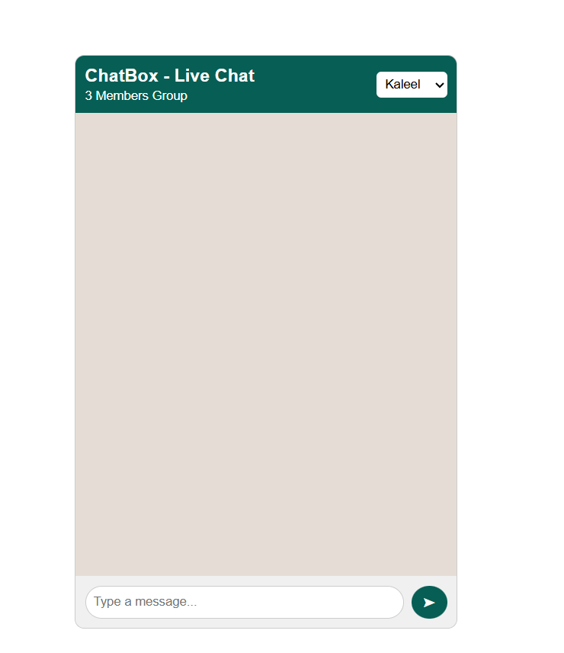

1. Introduction
This project is a simple WhatsApp-style group chat application developed using Angular framework. It is a frontend-only application designed to simulate live chat between three members.

2. Objective of the Project
The main objective of this project is to:
- Understand Angular standalone components
- Implement two-way data binding using ngModel
- Use structural directives like *ngFor and *ngIf
- Design a WhatsApp-like user interface using HTML and CSS
- Handle user interactions such as sending messages

3. Technologies Used
- Angular (Frontend Framework)
- TypeScript (Logic)
- HTML (Structure)
- CSS (Styling)

4. Features of the Application
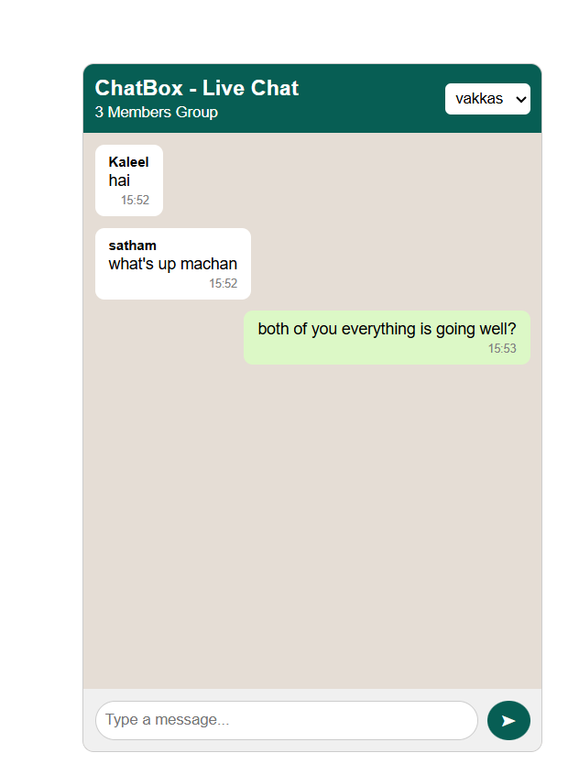
- Three members group chat
- User selection dropdown
- Message send functionality
- Time display for each message
- Enter key to send message
- WhatsApp-style chat bubbles
- Responsive layout design

5. Angular Concepts Used
- Standalone Components
- Property Binding
- Event Binding
- Two-way Data Binding [(ngModel)]
- Structural Directives (*ngFor, *ngIf)
- Bootstrap Application using bootstrapApplication()

6. Conclusion
The ChatBox - Live Chat project demonstrates the practical implementation of Angular fundamentals. It provides a simple and user-friendly chat interface similar to WhatsApp. This project helps in understanding component structure, data binding, and UI design in Angular.

